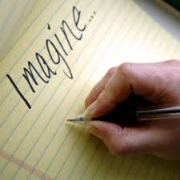
Writing Journal

The purpose of your writing journal is to practice thinking like an author. It is a space where you will be able to brainstorm, plan, think creatively, play around with ideas, learn new words and reflect on your thinking. Writing journal activities will most often be short and sharp, and the result will be that you end up with a resource of ideas that you may be able to use to turn into a polished piece of writing down the track.

Learning intention: to develop the ability to think creatively
Success Criteria: I will be successful if I can:
- Identify alternative resolutions to a narrative text

Your Task:

- Watch the text ‘Dead Bird’.
- Read the table below that outlines the orientation, complication and resolution of the text.
- In the space provided, brainstorm two alternative resolutions to the story.

Orientation | An old man joins a young boy on a park bench, and after noticing that he is upset, asks him what is wrong.
Complication | The boy tells the old man he is upset because his friends have ‘run off and left me’. The old man offers a story that the boy expects to be comforting, however it does not have a happy ending and the boy and the old man argue.
Resolution | The old man storms off in a huff and the boy is left sitting on his own again. A small bird that is sitting nearby dies.

Alternative Resolution 1
Alternative Resolution 2

