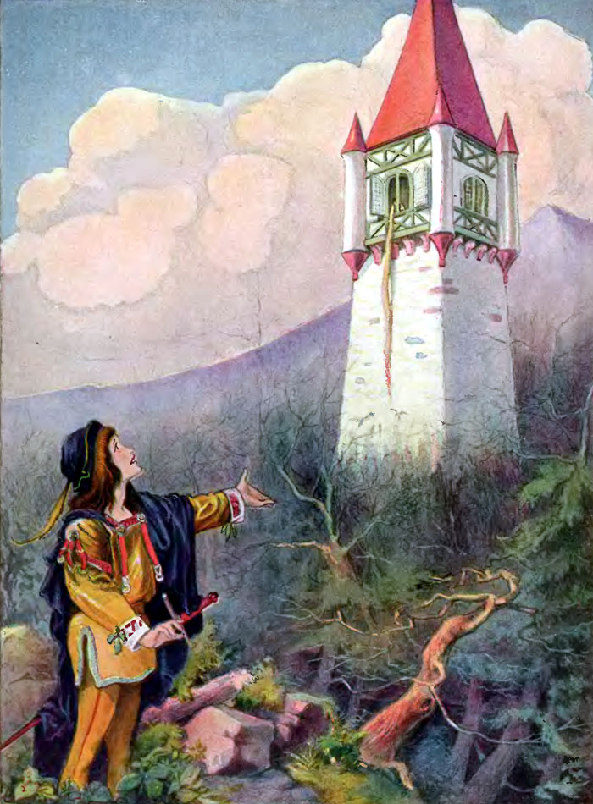
Analysing Rapunzel

Your Task:

- Analyse the characters in Rapunzel using the comparison chart below.

Character Name | Good | Evil | Mistreated in some way | Three adjectives to describe the character
The Enchantress
Rapunzel’s Mother
Rapunzel’s Father
The Prince

- Do variations of these characters appear in other stories/fairy tales? Which ones?

- How is this fairy tale the same or different from others you have read?

- Is it predictable? Why or why not?

