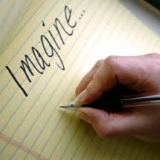
Writing Journal

The purpose of your writing journal is to practice thinking like an author. It is a space where you will be able to brainstorm, plan, think creatively, play around with ideas, learn new words and reflect on your thinking. Writing journal activities will most often be short and sharp, and the result will be that you end up with a resource of ideas that you may be able to use to turn into a polished piece of writing down the track.

Learning intention: to develop the ability to think creatively
Success Criteria: I will be successful if I can:
- Alter a narrative story in three ways

Your Task:

- Think about, or reread if necessary, the short story ‘Those Three Wishes’.
- Complete the BAR activity that is explained below. You need to do this in the form of a plan only. Please complete this in the table provided.

BAR:
This is creative thinking tool that starts from an existing idea, concept or thing. Then you need to:

B | Make something bigger, better or badder - such as give a character a bigger part, make a  problem or obstacle in the story bigger
A | Add something completely new - such as a new setting, character or complication
R | Remove, Reverse, Re-order something - take away something such as a character or problem,  reverse or re-order the sequence of events

B
A
R

