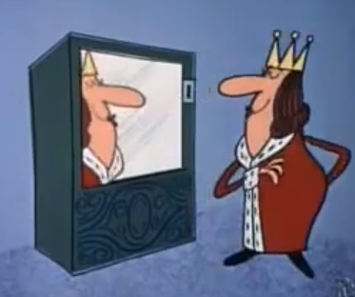
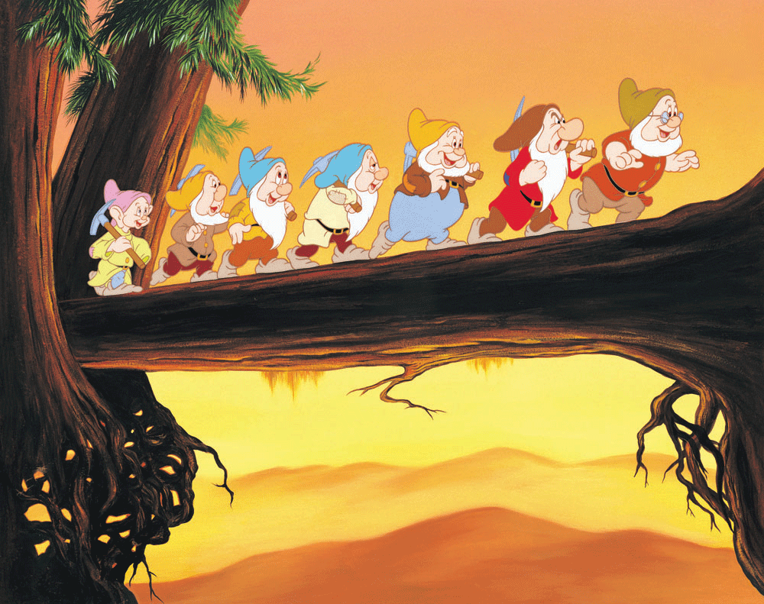
Snow White and the 7 Dwarfs - FRACTURED
The Brothers Grimm, 1812

- Reread the orientation, complication and resolution from the Brothers Grimm version of Snow White and the 7 Dwarfs.

Orientation | A Prince’s daughter grew up in a castle and was very happy despite the fact she had a wicked stepmother. Everyday the stepmother would ask the magic mirror "Mirror, mirror on the wall, who is the loveliest lady in the land?". The mirror would always say that the stepmother was, until one day it answered ‘Snow White’. The stepmother decided to have her killed.
Complication | The stepmother fed Snow White a poisonous apple that left her lifeless.
Resolution | The Prince gave Snow White a magical kiss and woke her up. They lived happily ever after.

- Identify the orientation, complication and resolution in the fractured version of Snow White and the 7 Dwarfs.

Orientation
Major Complication
Major Resolution

- Read the orientation, complication and resolution from the Brothers Grimm version of Rapunzel.

Orientation | A man and woman long for a baby. The man agrees to steal some Rapunzel from the evil Enchantress’ home at his wife’s insistence. He is caught by the enchantress and agrees to give up his baby in return for his life.
Major complication | Rapunzel is locked in a tower by the Enchantress who wants to keep her all to herself. Rapunzel’s hair is cut off when it is discovered that she has fallen in love with the Prince, and he is blinded. They can no longer see each other.
Major resolution | The Prince and Rapunzel meet again and her tears cure his blindness. They live happily ever after.

- Make a list of possible complications that are different to the one in the original tale. Also outline how these complications will be resolved, if you want it to be, or if it needs to be different to the original.

Complication | Resolution

- Choose the complication and resolution that you like the best, and create a plan in the form of 5-8 dot points that outline how your story will unfold. The orientation has been done for you.

- A man and woman long for a baby.
- The man agrees to steal some Rapunzel from the evil Enchantress’ home at his wife’s insistence.
- He is caught by the enchantress and agrees to give up his baby in return for his life.

