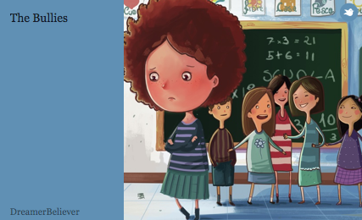
Themes in ‘The Bullies’

- Create a list of possible themes in the table below.
Themes in ‘The Bullies’

- In the space provided below, create at least three applied questions that link to the themes.

- In the space provided below, choose three of the applied questions above and record your answer.

