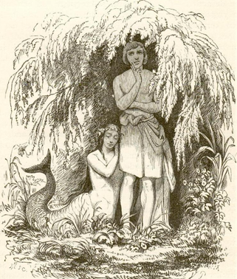
What are Fairy Tales?

Fairy tales are a type of narrative. They were originally part of a vast oral tradition of storytelling. This means that people used to tell these tales to others verbally, and as a result they were passed down from generation to generation. Because of this, their history is difficult to pinpoint until they were written down. Once a fairy tale is written down it is known as a literary fairy tale.

Some of the more famous fairy tales first came into print in 1697 and were recorded by Charles Perrault. These included Cinderella, Sleeping Beauty and Little Red Riding Hood. Later, in 1812, Jacob and Wilhelm Grimm (also known as The Brothers Grimm) recorded other classics including 'Rapunzel', 'Hansel and Gretel', and 'Rumpelstiltskin'. Hans Christian Andersen is considered a master of the form and most of the fairy tales he recorded were original. He published his first tales in a book called Fairy Tales Told for Children in 1835 and many of his stories are still well known today, including 'The Little Mermaid' and 'The Ugly Duckling'.

Fairy tales are set in the everyday world, but they aren't realistic; animals talk, the wind gives advice, and the dead spring back to life. The tales aren't usually set in the here and now; or in any identifiable time or place—they exist in the state of 'once upon a time'. Their characters are often nameless, or have generic names, as if to remind us that wonderful things can happen to anyone. And that strange and wondrous things can happen is never questioned: anything is possible. A child can become a bird, a man a monster, a girl in rags a Queen. Things can change for the better and justice will prevail. There are some fairy tales without a happily ever after—but there are no fairy tales in which no one is transformed. Listed below are some common elements that appear in fairy tales.

Common Elements of Fairy Tales

They often have:

- "Once upon a time...” as the opening line.
- Fantasy. Fantasy means an ‘alternate reality’. This just means a new world that operates very differently to what we would consider as ‘normal’. An example would be the enchanted forest.
- Clearly defined Good characters vs. Evil characters.
- Royalty present such as a beautiful princess/handsome prince.
- Magic (extraordinary events that happen in a ‘normal’ world). Examples of magic in fairy tales include giants, elves, talking animals, witches or fairies.
- A problem that needs to be solved.
- Repetition. Words or phrases may be repeated, or there may be several attempts at solving a problem.
- Poverty as a theme. For example, there may be a poor working girl or shepherd.
- Sibling rivalry (oldest versus youngest).
- Happy endings – “they all lived happily ever after.”
- A moral they are trying to teach (often to teach children not to talk to strangers or wander too far from home).

Common Elements of Fairy Tales – Analysing Rapunzel

Your task:

- Complete an analysis of Rapunzel to decide what common elements of fairy tales exist in this particular story. Using the table below, you need to tick any elements that you believe are present. You are also required to include evidence from the text. An example has been completed for you.
Common Element | Present in the fairy tale? | Evidence from the text
"Once upon a time...”
Fantasy
Good characters versus Evil characters
Royalty
Magic
A problem that needs solving
Repetition
Poverty
Sibling Rivalry
Happy endings
A moral | Y | If you do something wrong, then expect a punishment of some sort. This is seen in the text when Rapunzel’s father agrees to trespass into the enchantress’ property and steal from her. It was wrong to trespass and steal, and his punishment was that he had to give away his daughter.  When it was getting dark, he clambered down over the wall into the garden of the enchantress, hastily clutched a handful of the Rapunzel plant and took it to his wife.  It is also seen in the text when the enchantress decides to keep Rapunzel locked up. It was wrong to isolate her in the tower on her own, and her punishment was that she ended up being deceived by Rapunzel.  ‘Ah! you wicked child,’ cried the enchantress. ‘What do I hear you say! I thought I had separated you from all the world, and yet you have deceived me!’

- Identify the orientation, complication and resolution in Rapunzel.

Orientation
Complication
Resolution

